**Test Case**

1. **Introduction**

We will be testing Give Clinic Review.

Section 2 Black Box Testing will be testing one important control class and Section 3 White Box Testing will be testing two crucial methods.

**2 Black Box Testing**

**2.1 Testing “Give Clinic Review” Control Class**

|  |  |  |
| --- | --- | --- |
| **Field** | **Valid Test Case** | **Invalid Test Case** |
| **Rating** | * Any Number from 1 to 5 | * 0 |
| **Feedback** | * Any input | * Null Feedback |
| **User** | * Already sign in account | * Haven’t sign in account |
| **Clinic** | * Have select this clinic | * Does not select any clinic |

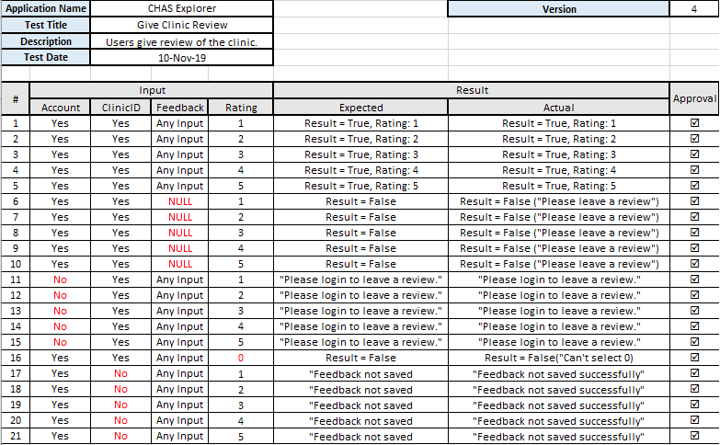

1. **White Box Testing**

**3.1 Control Flow Test: Save Review**

Method: saveReview()

Parameters: Clinic, feedback, rating, uid, email, photo, firebaseconnection, displayname

Return: boolean

Purpose: upload and save the review into database

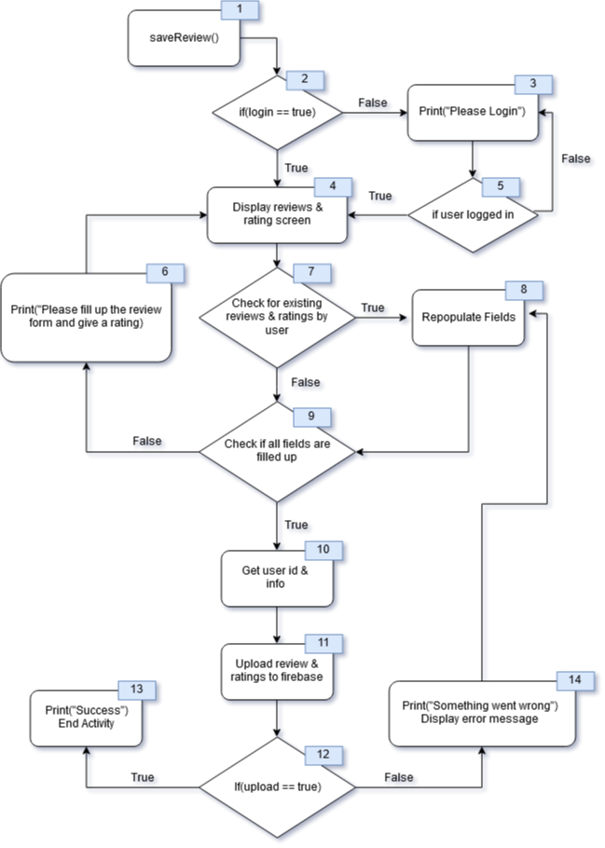

**Basis Paths:**a) 1,2,4,7,9,10,11,12,13

b) 1,2,3,5,4,7,9,10,11,12,13  
c) 1,2,4,7,8,9,10,11,12,13  
d) 1,2,4,7,9,5,4,7,9,10,11,12,13  
e) 1,2,4,7,9,10,11,12,14,8,9,10,11,12,13

**Test Cases:**a) User is logged in submits a new review without existing review found attached to user id.  
b) User is not logged in, logs in successfully and submits a new review.  
c) User is logged in and submit a review, but an existing review is found and fields are repopulated accordingly.  
d) User is logged in and submit a new review but user tries to submit an empty form.  
e) User is logged in and submit a new review, however for some reasons the server fails or form is incomplete and user is prompted to try again.  
  
**Execution Paths:**a) 1,2,4,7,9,10,11,12,13

b) 1,2,3,5,4,7,9,10,11,12,13  
c) 1,2,4,7,8,9,10,11,12,13  
d) 1,2,4,7,9,5,4,7,9,10,11,12,13  
e) 1,2,4,7,9,10,11,12,14,8,9,10,11,12,13

**Cyclomatic Complexity:**[Conditions + 1] = [5 + 1] = **6**   
[Edges - Nodes + 2] = [18 - 14 + 2] = **6**

**3.2 Control Flow Test: Search Clinic On Map**

Method: searchClinicOnMap ()

Parameters: Query

Return: boolean

Purpose: Search Clinic by Clinic Name/Phone Number/Postal Code and show clinic location on map

**Basis Paths:**a) 1,2,4,5,6,7,9,10,6,11,12

b) 1,2,3

c) 1,2,4,3

d) 1,2,4,5,6,7,10,6,11,3

e) 1,2,4,5,6,8,10,6,11,3

f) 1,2,4,5,6,8,9,10,6,11,12

**Test Cases:**a) User types “Peace” and press search, all the Clinics which contains the keyword “Peace” in their Clinic name will be plotted on the map.

b) User types nothing and just press search.

c) User types “@#Peace@Clinic!” and press search.  
d) User types “Harvard Clinic” and press search, no clinic containing the keyword in their Clinic Name is found after looping through the data set. “No Results Found” will be printed out.

e) User types “712345” and press search, no clinic containing the keyword in their Postal Code is found after looping through the data set. “No Results Found” will be printed out.

f) User types “732899” and press search, the Clinic with that Postal Code will be plotted on the map.

**Execution Paths:**a) 1,2,4,5,6,7,9,10*,6,11,12

b) 1,2,3

c) 1,2,4,3

d) 1,2,4,5,6,7,10*,6,11,3

e) 1,2,4,5,6,8,10*,6,11,3

f) 1,2,4,5,6,8,9,10*,6,11,12

\***While loop (Number 6) will be repeated 1063 times since there are 1063 Clinics in the given dataset.**

**Cyclomatic Complexity:**[Conditions + 1] = [6 + 1] = **7**   
[Edges - Nodes + 2] = [17 – 12 + 2] = **7**

**3.2 Get All Feedback for Clinic**

Method: getAllFeedbackForClinic()

Parameters: Clinic Code

Return: ArrayList <Review> newReviewAI

Purpose: To Retrieve all Reviews

